**1.Titanic Project:**

* importing required modules and load the data.

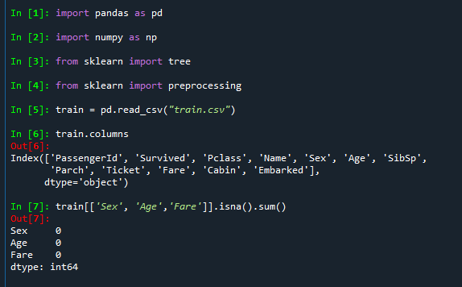

* Create a model and train data with three independent variables.

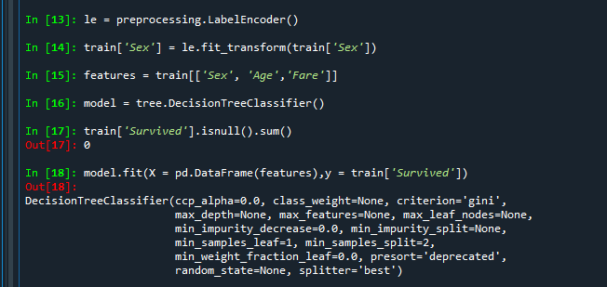

* Upload the dot file with Decision tree.



* Import test data and create the model.

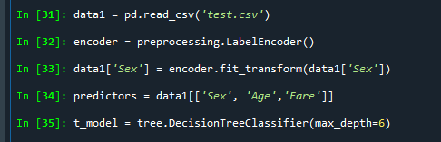

* Predict the Survived people with given test data by using train model.

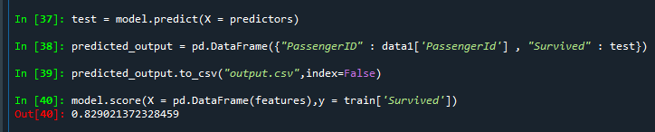

* Decision Tree image for this model.
* Total samples are 889, Gini index is 0.472.
* Here Sex variable is divided into two categories if Sex <= 0.5 is True – Female otherwise Male.

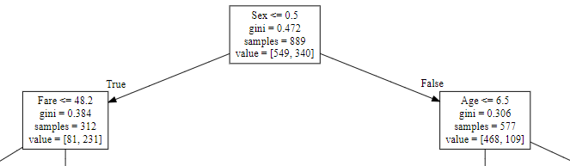

* Similar to above Sex variable split, other variables (Age & Gender) splits until sample comes to same category for Female variable.

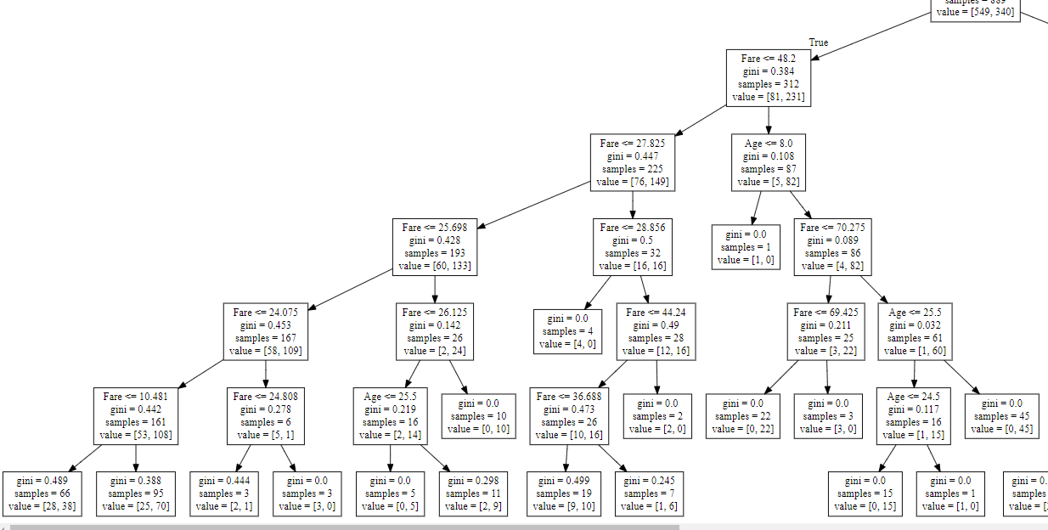

* Same like Female samples, Male samples are splits into different samples according to the other variables (Age & Fare) until the sample came to same category.

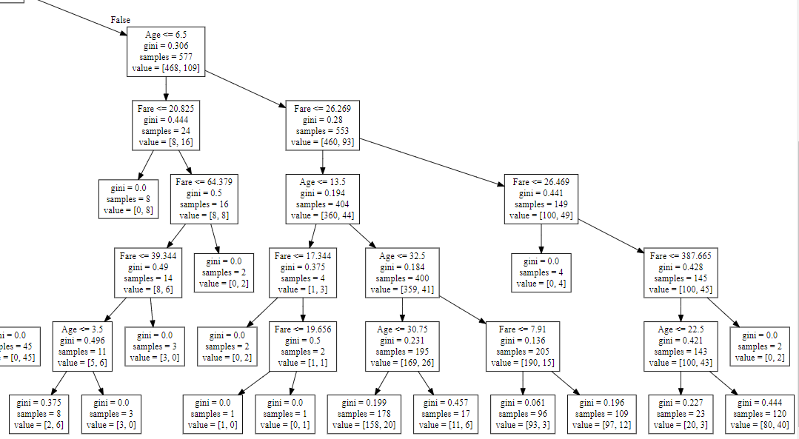

**2. Bank Loan Project:**

* importing required modules and load the data.

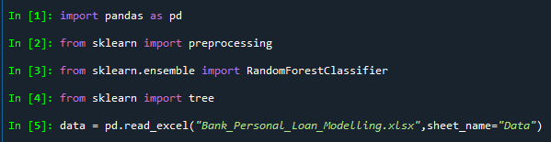

* Drop the unnecessary variables and create a Random Forest model

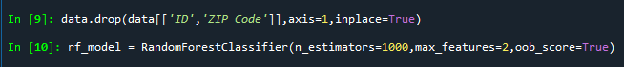

* Addition of independent variables as features.



* Fit the Random Forest model with features and Dependent variable, and generate the OOB value.

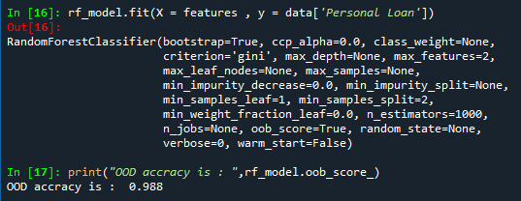

* By the above model we get the importance of independent variables

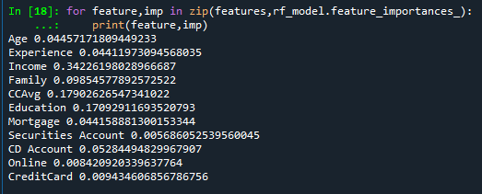

* Generate the Decision Tree model with important

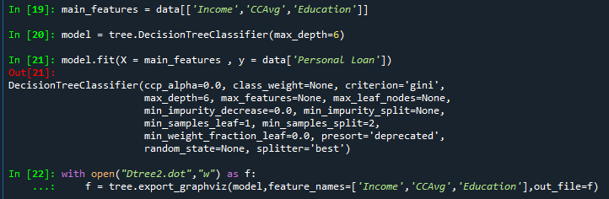

* Decision Tree image for this model.
* Total samples are 5000, Gini index is 0.174.
* Here Income variable is divided into two categories according to Income <= 113.5.

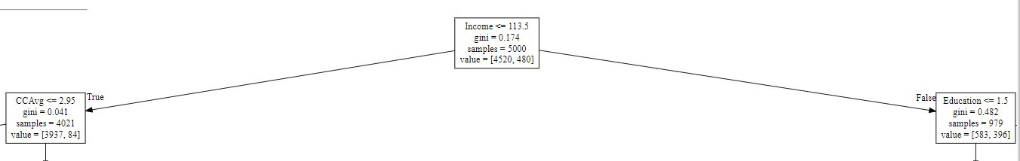

* From above split, again these samples are splits into two as CCAvg <= 2.95.
* Here other splits from below 2.95 CCAvg according to Education variable.

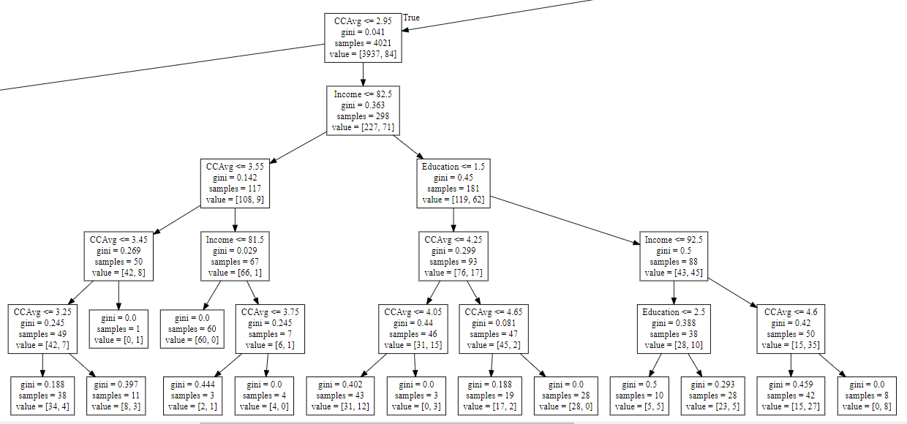

* Other split from CCAvg <= 2.95, again splits into two and it continuous with Education variable

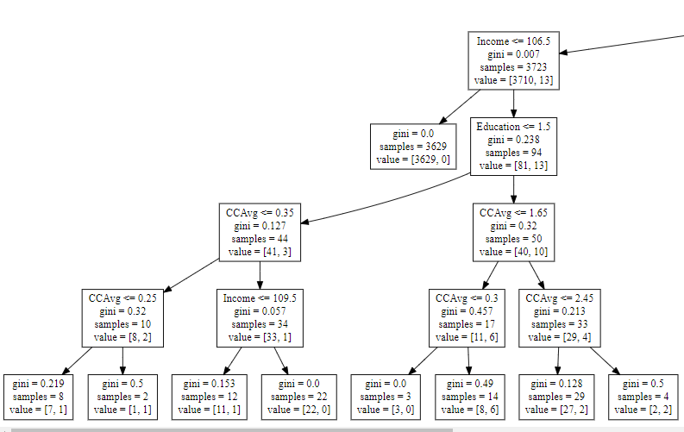

* From starting split of Income <= 113.5, samples divide into other by Education variables.

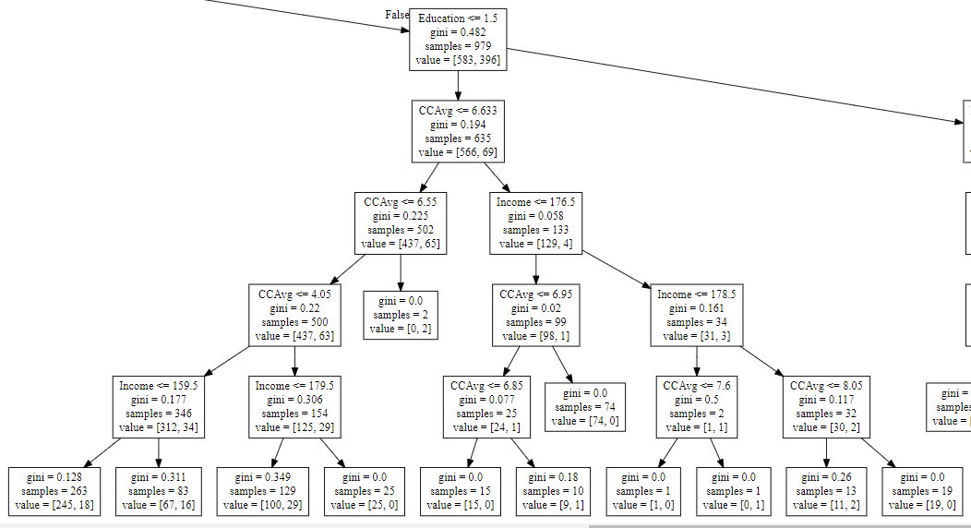

* From Education sample, it splits again by Income.

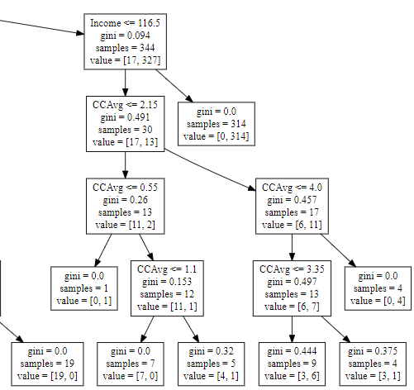

**3. Attrition Project:**

* Import required modules and get a dataset

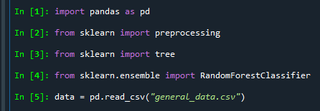

* Change the categorical variable into numerical by using Label Encoder.

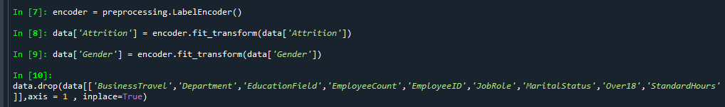

* Create a Random Forest model with features like n_estimators, max_features and oob_score.

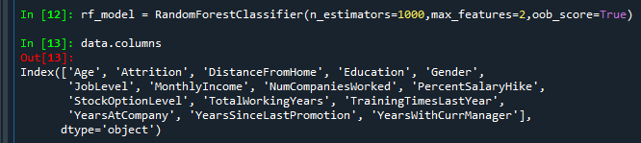

* Fill the null values with their respective mean values.





* Add features to dataset.



* Fit the Random Forest with X and Y variables and get OOD score.

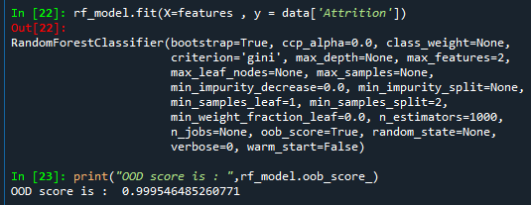

* Get important variables

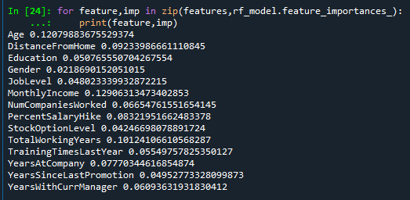

* With important variables create and fit the Decision Tree model.

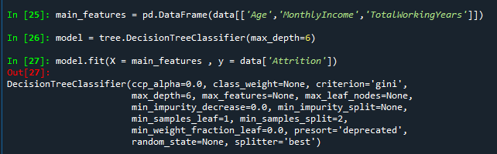

* Generate the dot file from the tree model.



* Decision Tree image for this model.
* Total samples are 4410, Gini index is 0.27.
* Here Income variable is divided into two categories according to TotalWorkingYears <= 1.5.

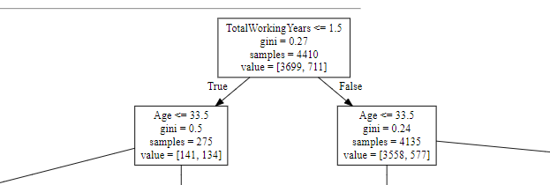

* From the above split, again it splits into the various samples by using Age and MonthlyIncome variables.

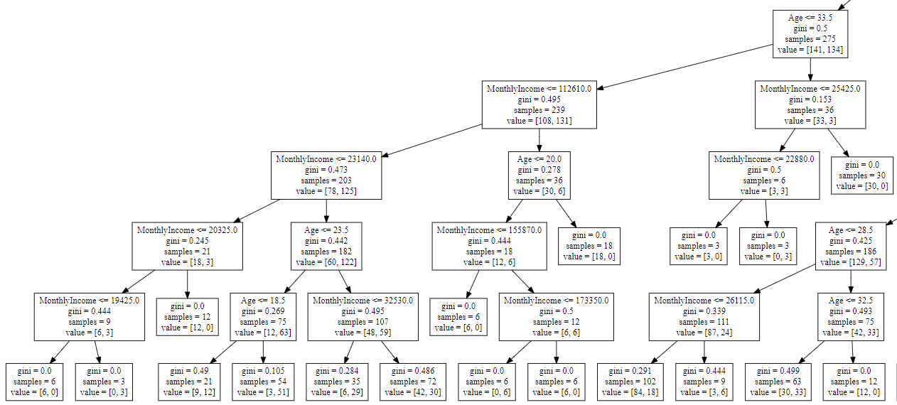

* From the above split, again it splits into the various samples by using Age and MonthlyIncome variables.

